Sign up for
TEXT REMINDERS!
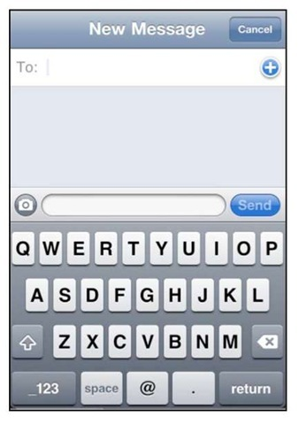
Using Remind, a free texting service, I’ll send reminder text messages about homework, quizzes, tests and project. Here’s how…
Text @ge698 to 81010 if you are in Principles of Family and Human Services
Text @ge698 to 81010 if you are in Interior Design 1

Sign up for
TEXT REMINDERS!
Using Remind, a free texting service, I’ll send reminder text messages about homework, quizzes, tests and project. Here’s how…
Text @ge698 to 81010 if you are in Principles of Family and Human Services
Text @ge698 to 81010 if you are in Interior Design 1

